  This exam paper must not be removed from the venue | Venue | ____________________
 | Seat Number | __________
 | Student Number | |__|__|__|__|__|__|__|__|
 | Family Name | ____________________
 | First Name | ____________________

School of Biological Sciences
SUPPLEMENTARY EXAMINATION
Semester One Examinations, 2022
BIOL3360 Analysis & Communication of Biological Data
This paper is for St Lucia Campus and St Lucia Campus (External) students.

Examination Duration: 90 minutes  Reading Time: 10 minutes  Exam Conditions:  Learn.UQ invigilated  File upload to Turnitin  This is an Open Book examination  During Reading/Planning Time - Students are encouraged to review and plan responses to the exam questions  Materials Permitted In The Exam Venue:  Personal laptop  Materials To Be Supplied To Students:  None  Instructions To Students:  none | For Examiner Use Only  Total _________
  Question | Mark

Question 1: Write a function using R

Ecologists in Switzerland were interested in the population dynamics of the frog, Rana temporaria in a pond near Bern. In particular, they were interested in whether the population was declining. They recorded the population abundance of frogs every year from 1970 to 1997.

The first 6 values of the R data.frame (called “frogs”) are below:

> frogs <- read.csv(“frogs.txt”) ## read in the data frame
> head(frogs)## look at the first 6 rows
Year N
1 1970 548
2 1971 508
3 1972 496
4 1973 397
5 1974 588
6 1975 471

Write R code to conduct a linear regression of N against Year for the frogs data.frame. (hint: use the lm() function.) (5 marks)

Insert answer box

Question 2: Prepare a figure for publication

The researchers plotted their data, plotting N against Year using the following code:

with(frogs, plot(N ~ Year))

which produced the following plot:
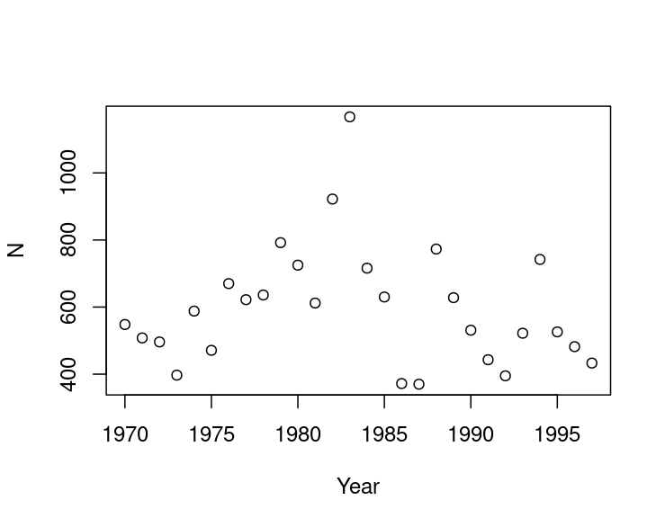

The results of the linear regression in Question 1 were:

Residuals:
Min 1Q Median 3Q Max
-223.67 -128.97 -37.90 72.32 568.77

Coefficients:
Estimate Std. Error t value Pr(>|t|)
(Intercept) 5089.591 8397.859 0.606 0.550
Year -2.265 4.234 -0.535 0.597

Residual standard error: 180.8 on 26 degrees of freedom
Multiple R-squared: 0.01089, Adjusted R-squared: -0.02716
F-statistic: 0.2862 on 1 and 26 DF, p-value: 0.5972

- Using the above plot, describe three features you would add, remove or alter that will improve the plot for publication in a scientific journal. [3 marks]

Insert answer box

- From the R output above, which aspects of the analysis should be reported in a scientific paper? [2 marks]

Insert answer box

Question 3: Explain an analysis to other scientists

Write an explanation about how the model in question 2 was conducted. The explanation should be accurate and suitable for inclusion in the methods section of a scientific paper (6 marks)
Insert answer box

Question 4: Write the biological story

Using the output from question 2 above, write one or two sentences that communicates the biological story of the results. Your sentence(s) should include appropriate wording and the necessary statistics and outputs, correctly formatted for inclusion in a scientific paper. (4 marks)
TIP - You may need to attempt more than one draft of your sentences

Insert answer box

Question 5: Explain an analysis to other scientists – drop bears

Write an explanation, suitable for inclusion in the methods section of a scientific paper, for how to conduct a l mixed-effects model. Please use the study and data set below as the basis for your explanation. (6 marks)

“Pseudemoia spenceri is a small, arboreal skink found in highland areas from the Blue Mountains in NSW down to Victoria. A researcher was interested in determining whether the numbers of skinks was related to the diameter of trees on quadrats. At each of 5 sites, they measured the mean diameter (at breast height) of trees in 20 quadrats, and also counted the number of skinks in each quadrat. The data are available in the file “SkinkDat.csv.” “

## code
dat <- read.csv("SkinkDat.csv")
head(dat) ## first 6 lines of data
site MeanDBM numSkinks
1 1 12.22 60
2 1 15.60 91
3 1 5.38 32
4 1 13.58 61
5 1 13.64 76
6 1 0.02 28
library(lmerTest)
fit <- lmer(numSkinks ~ MeanDBM + (1|site), data=dat)

summary(fit)
## Output follows...
Linear mixed model fit by REML. t-tests use Satterthwaite's method ['lmerModLmerTest']
Formula: numSkinks ~ MeanDBM + (1 | site)
Data: dat

REML criterion at convergence: 387.7

Scaled residuals:
Min 1Q Median 3Q Max
-1.8259 -0.5890 -0.1165 0.5823 2.4510

Random effects:
Groups Name Variance Std.Dev.
site (Intercept) 12.64 3.556
Residual 140.04 11.834
Number of obs: 50, groups: site, 5

Fixed effects:
Estimate Std. Error df t value Pr(>|t|)
(Intercept) 1.4247 3.2187 9.7167 0.443 0.668
MeanDBM 4.9474 0.2442 43.8319 20.257 <2e-16 ***
---
Signif. codes: 0 ‘***’ 0.001 ‘**’ 0.01 ‘*’ 0.05 ‘.’ 0.1 ‘ ’ 1

Correlation of Fixed Effects:
(Intr)
MeanDBM -0.697

Question 6: Write the biological story

- From the R output in question 5 (above), which aspects of the analysis should be reported in a scientific paper? [2 marks]

Insert answer box

- Based on the results of the analysis, describe if/how the number of skinks is related to the diameter of trees. [2 marks]

Insert answer box

- Write the results of the skink study above in one or two sentences so they correctly communicate the results in a way that is appropriate for a scientific research paper. (4 marks)
TIP - Remember to tell the biological story, you may need to attempt more than one draft of your sentences
Insert answer box

Question 7: Communication conventions

Most scientific papers follow the conventional format of abstract, introduction, methods, results, discussion. Thinking about the acronym G.A.P., justify how and why you would change this format for the Head manager of Moreton Bay Water Catchment (who oversees the water quality, recreational use and biodiversity conservation of the water catchment). In your answer indicate what you would emphasise or add to a report to meet the priorities and interests of this audience. (6 marks)

Insert answer box

END OF EXAMINATION

